Ex. No 5: Use Autopsy to create a case and import evidence

Date:

Description


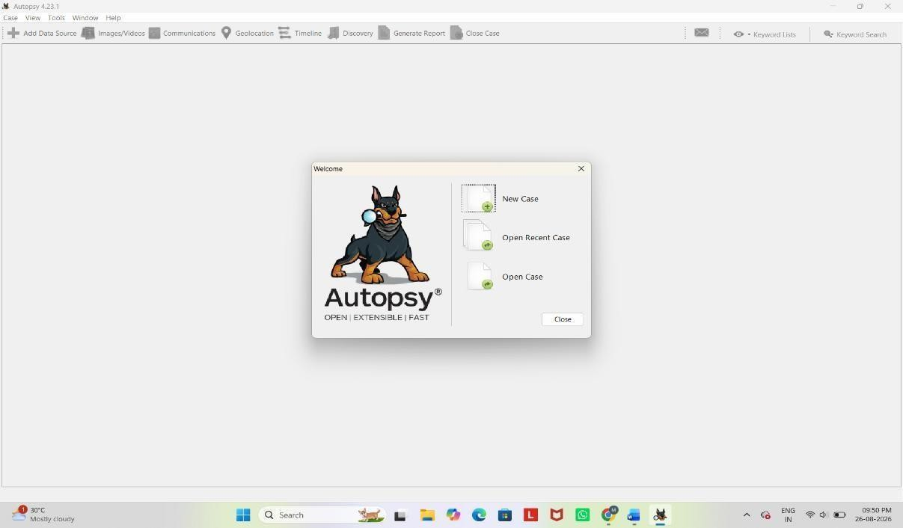
Autopsy is an open-source digital forensics platform used for analyzing and extracting data from digital devices. Here's a step-by-step process on how to use Autopsy for a basic forensic investigation:

Installation
  - Download and Install: Autopsy can be downloaded from the official website. Follow the installation instructions based on your operating system (Windows, Linux, or macOS).

Starting a New Case
  - Open Autopsy: Launch the application after installation.

Create a New Case:
    - Click on New Case.
    - Enter the case name and location where the case data will be stored.
    - Fill in the details like the case number, examiner's name, etc., and click Next.

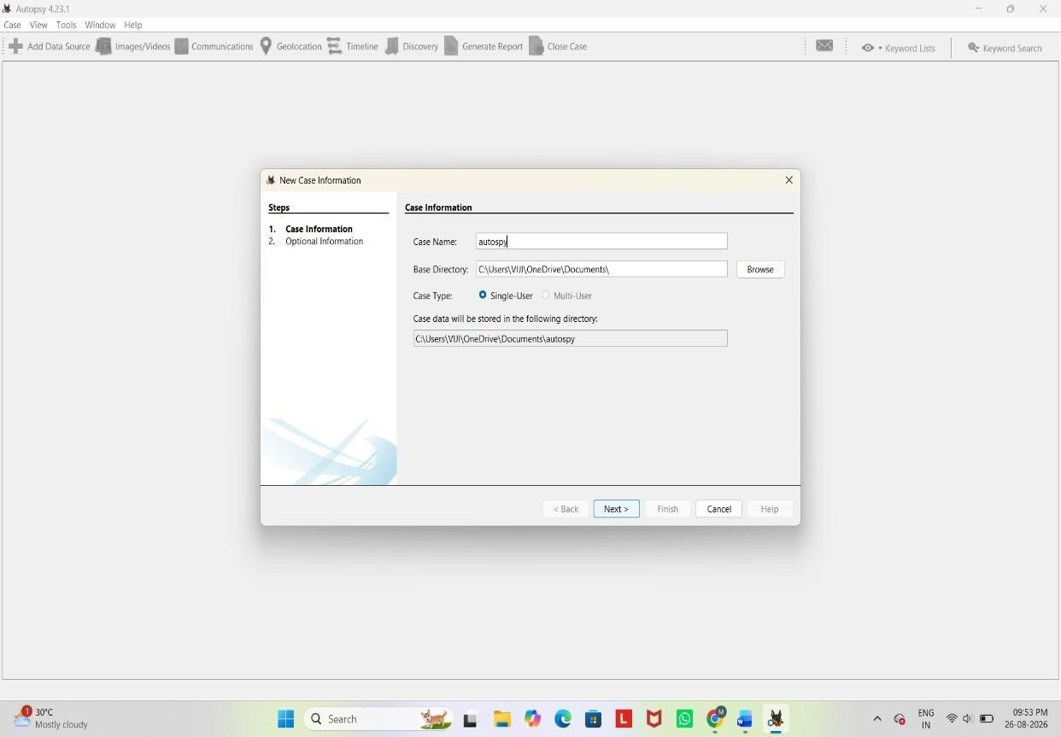

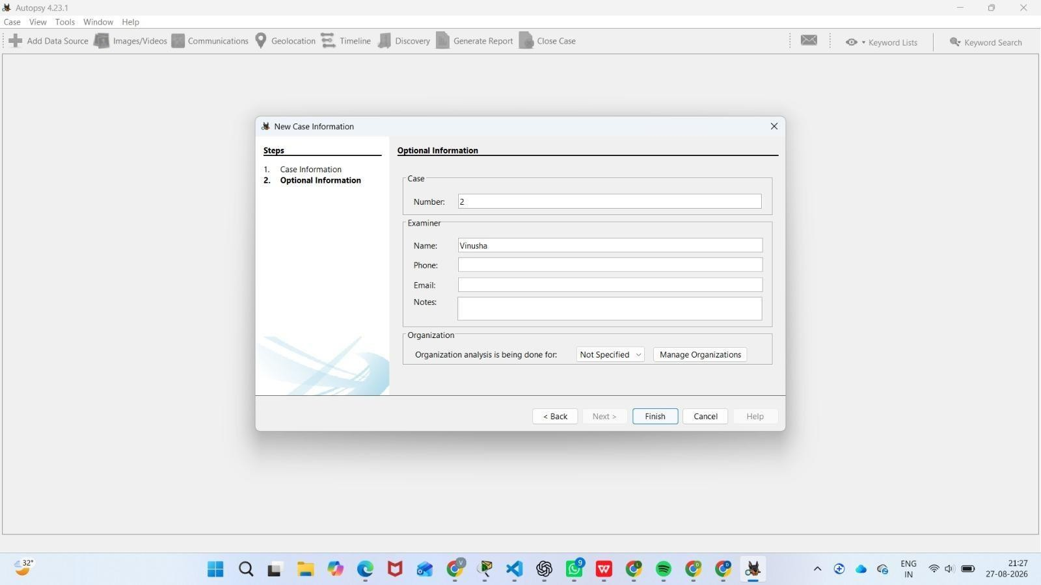

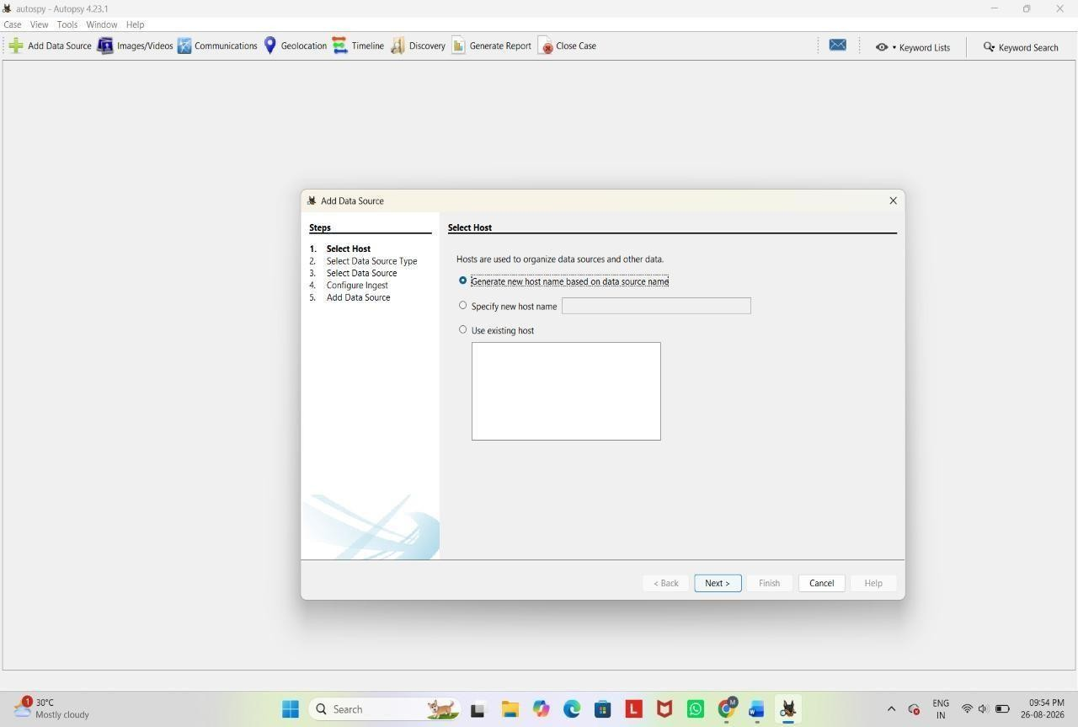
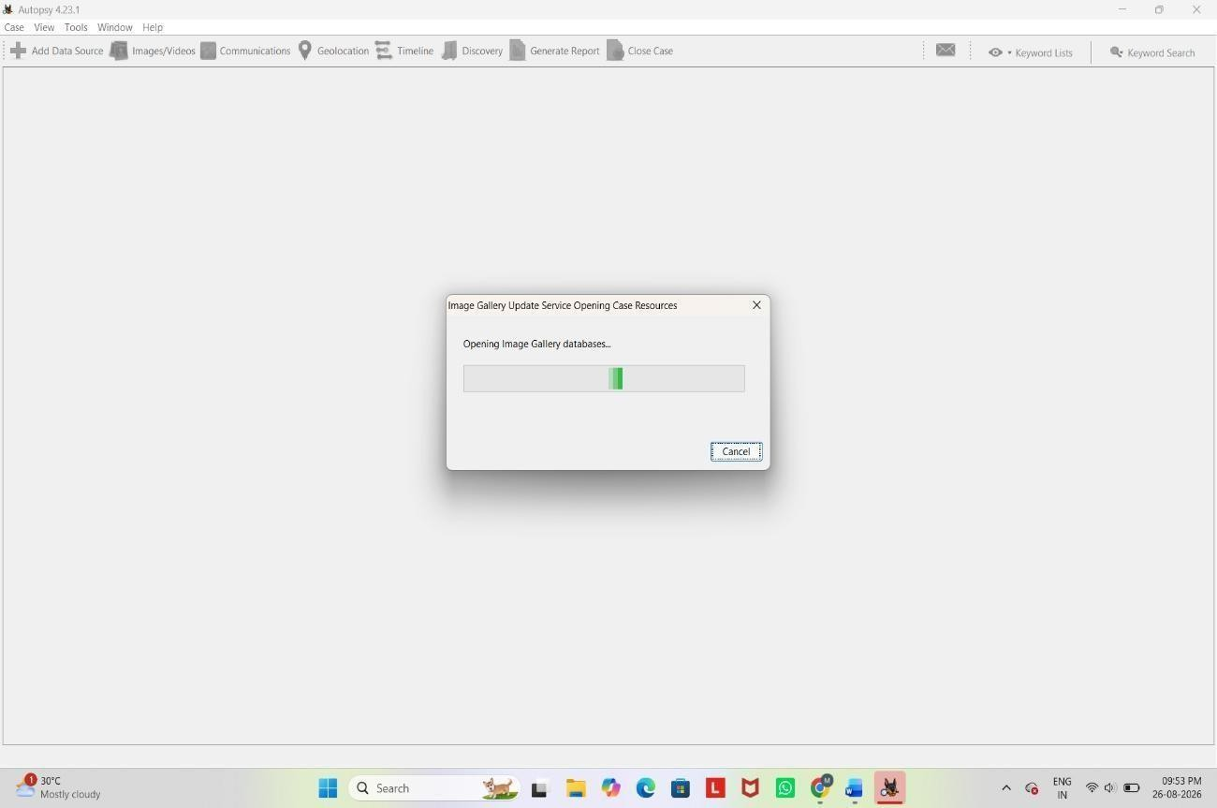

Adding a Data Source
  - Choose the Type of Data Source:
    - After creating a case, you'll be prompted to add a data source.
    - You can add disk images, directories, logical files, or local disks.

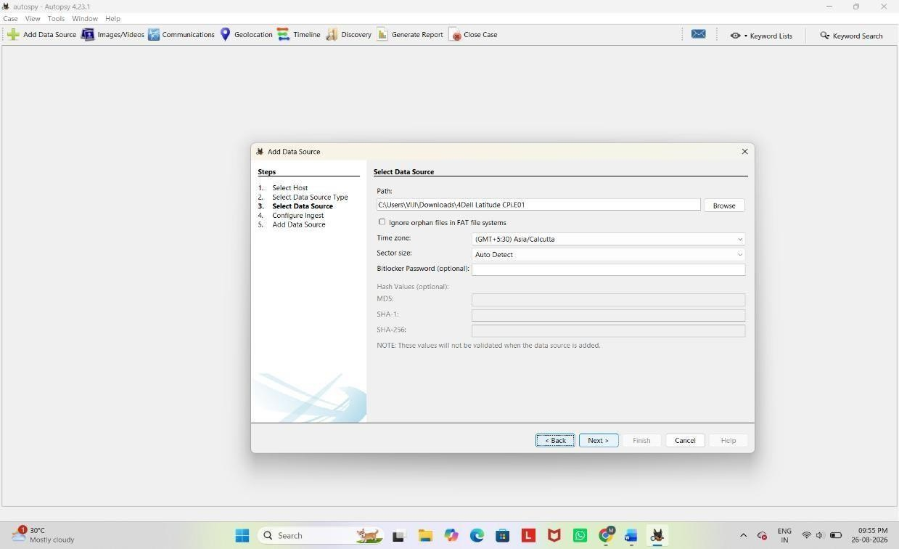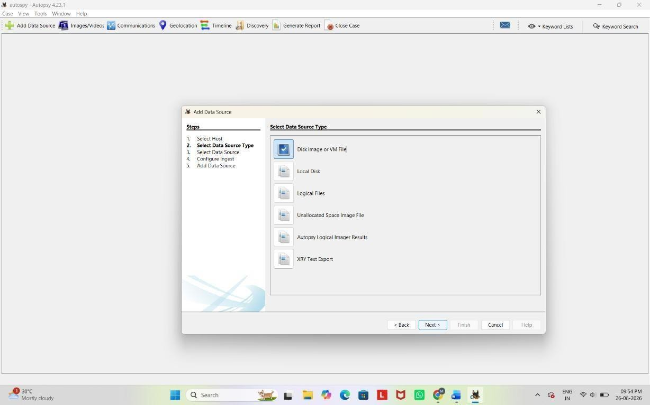

Select the Data Source:
Browse to the location of the image file (e.g., .E01, .dd, or .raw), physical disk, or directory you want to analyze.

Configure Ingest Modules:
    - Autopsy allows you to select specific analysis modules such as File Type Identification, Keyword Search, Hash Lookup, etc.

    - You can enable or disable these based on your investigation needs.
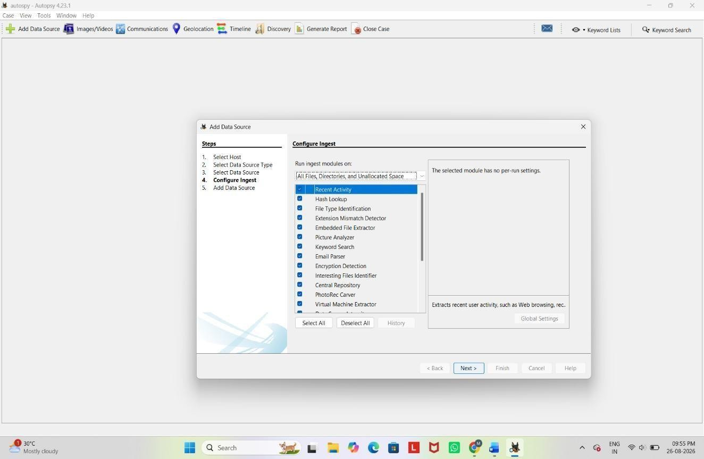

Start Analysis: Click Next to start the analysis.
4. Initial Analysis and Overview
Ingest Progress: As Autopsy processes the data source, you'll see the progress in the lower-left corner.
Explore the Resulting Artifacts:
Autopsy automatically categorizes findings such as web artifacts, file system metadata, and communication records.
Use the Tree Viewer:
On the left pane, you’ll see a tree structure where you can explore different aspects like File System, Web History, Email, etc.

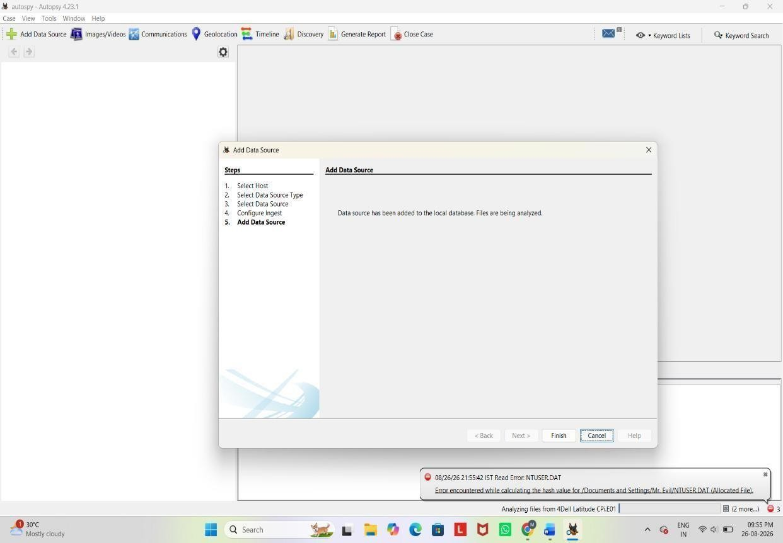

5. Detailed Analysis
Keyword Search:
You can perform specific keyword searches using the Keyword Search module.
Use pre-configured lists or enter custom keywords.
File Analysis:
Navigate through files and folders under the File Types or File System section. Open, view, or export files for further examination.
Timeline Analysis:
Use the Timeline module to visualize events based on timestamps. This can help track user activity over time.
Hash Analysis:
Compare file hashes with known databases to identify known good or bad
files.

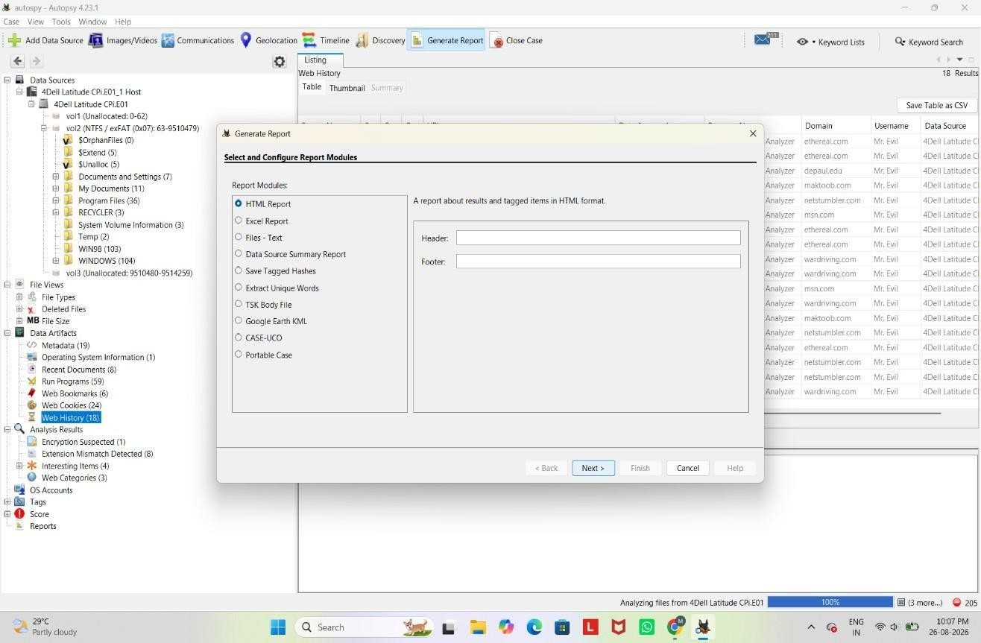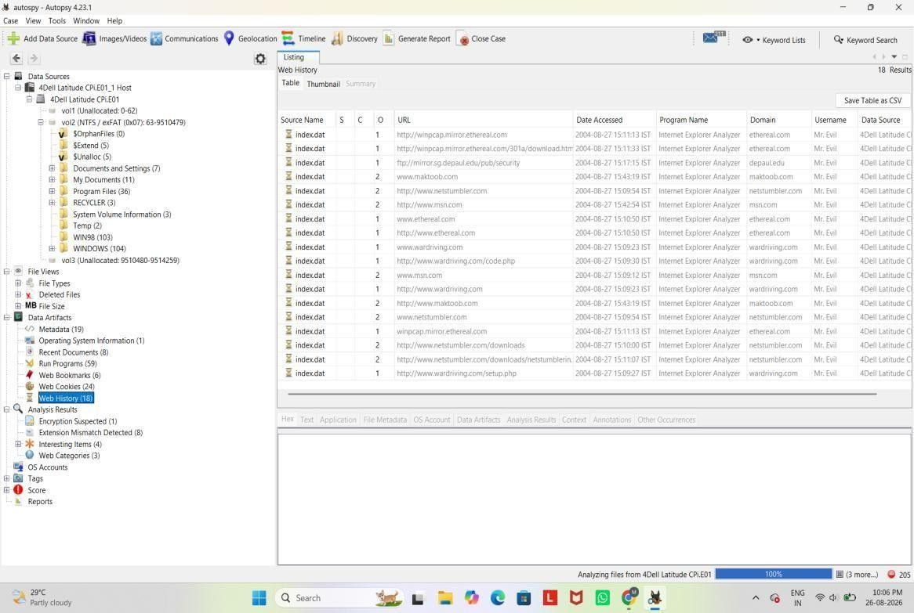

Reporting
  - Generate a Report:
    - After analyzing the data, click on Generate Report from the toolbar.
    - Choose the type of report (HTML, CSV, Excel, etc.).
    - Select which parts of the analysis you want to include in the report.

Export Findings:
    - Export individual files or artifacts that you need for your report or further analysis.

Final Review:
    - Review the report to ensure it includes all relevant information.
    - Save or print the report for use in your case.
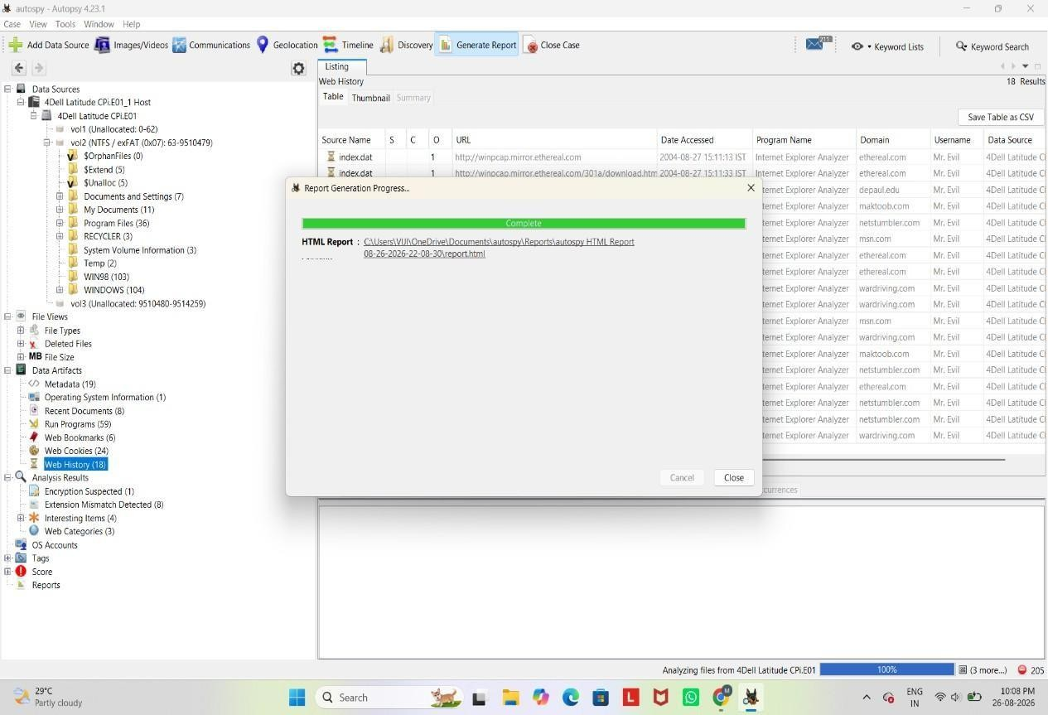
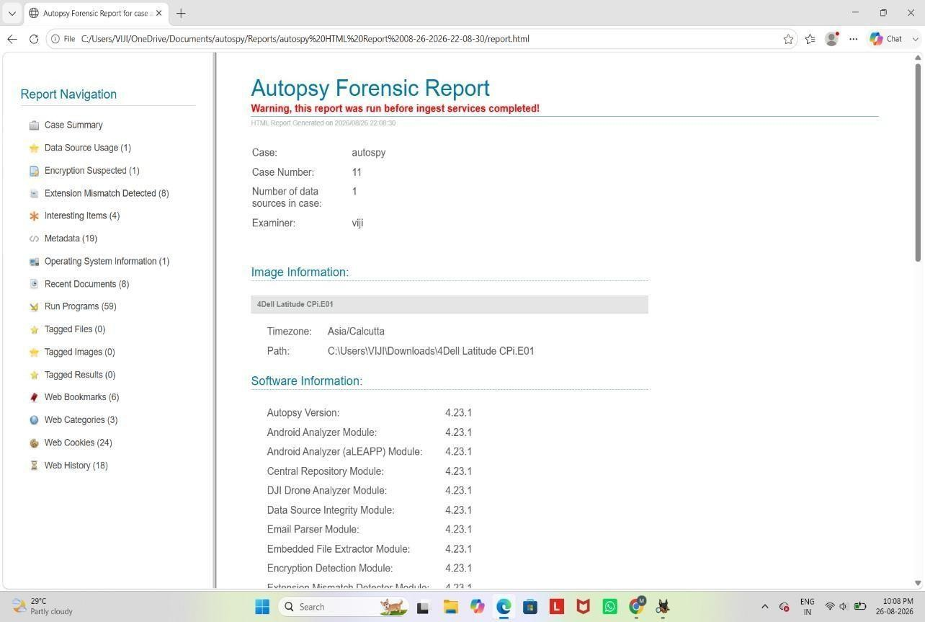

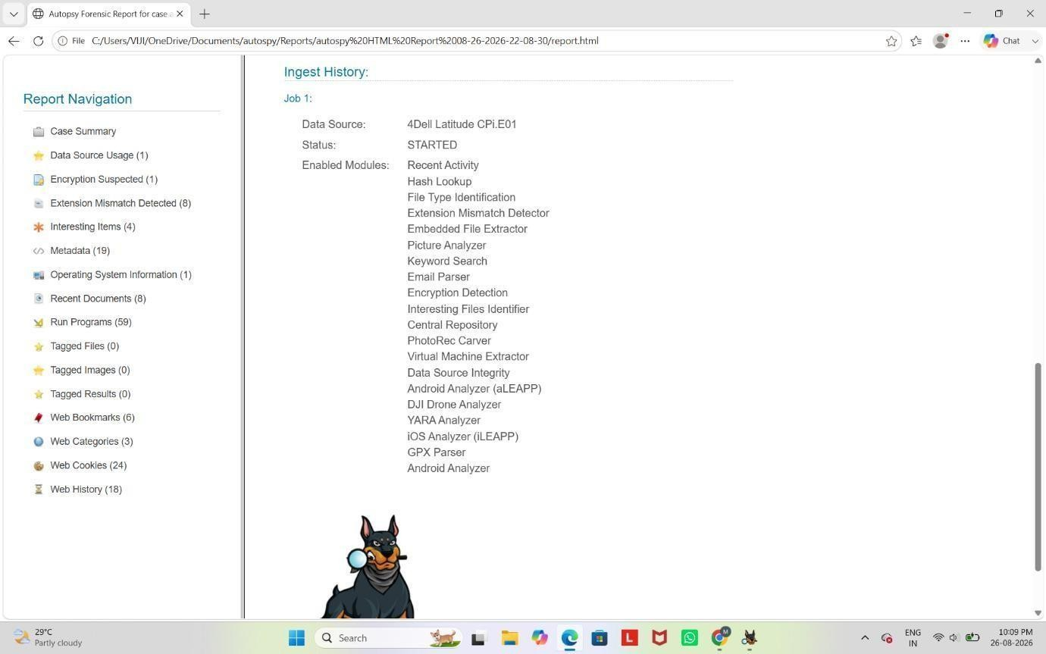

- Case Closure
Close the Case:
Once you have completed your investigation, close the case within Autopsy.
Archiving:
Ensure all data and reports are properly archived according to your organization's policies.
- Advanced Features (Optional) Custom Ingest Modules:
Autopsy allows for custom modules to be added if you need specific analysis tools not included by default.
Collaboration:
Autopsy can be configured for multi-user cases if you’re working in a team environment.

Rubrics

Criteria & Marks Assigned | Mark Allotted | Mark Awarded
1. GitHub Activity & Submission Regularity | 3
2. Application of Forensic Tools & Practical Execution | 3
3. Documentation & Reporting | 2
4. Engagement, Problem-Solving & Team Collaboration | 2
Total | 10

RESULT: A forensic case was successfully created using Autopsy, and the digital evidence 4Dell Latitude CPi.E01 was imported for analysis. The evidence was processed using ingest modules, and artifacts such as files, metadata, web history, communication records, keywords, timelines and hashes could be examined. The Case Creation, Add Data Source, Ingest Modules, Tree Viewer,Keyword Search, File Analysis, Hash Analysis and Report Generation features were used, and the forensic report was generated so that the case could be reviewed and properly archived.

